Draft, 18 APR 2019

***CASO Panel Bios***

***“Leveraging Culture and language in ‘Influence’ Operations***

*(21 May 2019)*

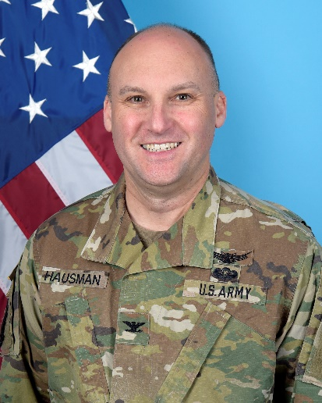COLONEL GARY M. HAUSMAN

Commandant

Defense Language Institute Foreign Language Center

_____________________________________________________

COL Hausman was commissioned in the U.S. Army in 1994 as a Military Intelligence Officer from the University of California at Irvine. He served tactical assignments at the 4th Infantry Division at Fort Carson, Colorado and 525th Battlefield Surveillance Brigade at Fort Bragg, North Carolina. He also served operational assignments at the Joint Special Operations Command and strategic assignments at the National Security Agency. He led the 743rd Military Intelligence Battalion, Buckley Air Force Base, Denver, Colorado in 2012-2014. Recently, he served at Army Cyber Command and at the United States Cyber Command. In June 2018, COL Hausman assumed command as the DLI Commandant, Presidio of Monterey, California. Gary and his high school sweetheart wife Michelle have two sons, Thomas and Benjamin.

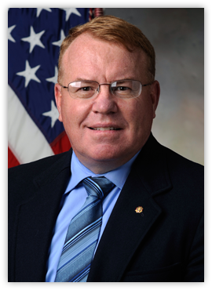Mr. George M. Dallas is the Director of the Marine Corps’ Center for Advanced Operational Culture Learning (CAOCL), Marine Corps University, located in Quantico, Virginia. CAOCL serves as the central Marine Corps organization for Language, Regional expertise and culture (LREC) training and education for the General Purpose Force. In addition to meeting the training and educational needs of the Marine Corps, CAOCL provides direct operational support to forward deployed Marines. Additionally, CAOCL hosts the Translational Research Group that provides social and behavioral science research for CAOCL and for the larger Marine Corps. Mr. Dallas is a retired Marine colonel with over 30 years of active service. He has commanded at every level from platoon to the 3rd Marine Division in Okinawa Japan. Mr Dallas is married to the former Kathleen Ann DeClercq and they have two adult sons.

Mr. Walter H. Ward, Jr., (Howard) is the Director of the Air Force Culture

and Language Center (AFCLC) at Air University, Maxwell AFB, AL. The AFCLC is a team of 50 military, Air Force Civilian, and contract personnel that support the application of airpower by enabling seamless operation with many air forces using culture, regional expertise, and language education and training. The AFCLC develops officer and enlisted Airmen proficient in language, culture and negotiation competencies covering 95 languages through the Language Enabled Airman Program (LEAP). The AFCLC also reaches over 210,000 Airmen per year through online training, Community College of the Air Force courses, officer professional military education, General Officer pre-deployment training, social media, and culture field guides.

Mr. Ward is a retired colonel and his most recent operational assignment was the Commander, 317th Airlift Group, Dyess Air Force Base, Texas. He commanded six squadrons, consisting of 1,200 aviators, maintenance professionals and support personnel, and 28 C-130J aircraft engaged in worldwide combat aerial delivery operations.

***U N I T E D S T A T E S A I R F O R C E***