***CASO/DHS Panel Bios***

**"The Changing Landscape of Homeland Security in Light of the Pandemic and** **Societal Unrest"** *(24 July 2020)*

**Mark Kerry**

**Bio June 2020**

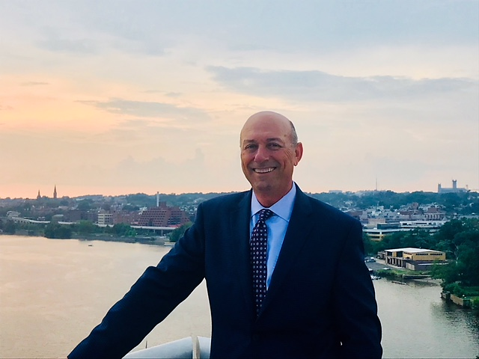Mark Kerry serves as Planning Division Leader for the Department of Homeland Security Joint Incident Advisory Group, or JIAG. His responsibilities include developing Department and interagency operational plans and providing decision support products to Department senior leaders to address crises and contingencies.

Having served in the military, civilian and federal government sectors, he has broad experience in emergency management, counter-terrorism, border security, public health, mass migration, countering weapons of mass destruction, and responding to man-made/natural disasters at the national and state level. He develops solutions to address national problems or contingencies which includes resolving intra-departmental and interagency policy and operational conflicts inherent in the development and execution of U.S. government operational plans. He also teaches a DHS standardized national plan development process to federal employees.

As the leader of a U.S. Army Human Terrain Team in Herat, Afghanistan and as the leader of the flagship Human Terrain Analysis Team in Kabul, Afghanistan, he coordinated five Human Terrain Teams to produce a first of its kind, national-scope, long-range report titled *Report on the Perception of the Afghan Population on the Legitimacy of the Afghan Elections of 2014*. He also led the development of the national Report on the *Viability of the Afghan Military after U.S. Withdrawal*.

Mark holds a Master of Science degree from the U.S. Army War College and a Bachelor of Science from Louisiana State University.

He is the author of *Tigers of the Tigris: An American Advisor’s Journey Through Culture, Religion and Intrigue in Building the Iraqi Army*. This book examines the experiences of a military advisor in Iraq through the lenses of culture and religion. It focuses on counterinsurgency techniques of influencing powerbrokers and opinion leaders such as tribal leaders and religious clerics.



**Mr. Robert C. Garven, Assistant Professor, Department of Army Tactics, U.S. Army Commandand General Staff College.**

Lieutenant Colonel (Retired) Robert C. (Bob) Garven is an Assistant Professor of Military Tactics with the Department of Army Tactics Directorate, Command and General Staff School at Fort Leavenworth, Kansas, where he has taught since 2003. He holds a Bachelor’s of Science Degree in Physical Education and Biology from the University of Kansas and a Masters in Liberal Arts, with an emphasis in Leadership and Management from Baker University, Baldwin City, Kansas. LTC (Ret.) Garven was a Distinguished Military Graduate of ROTC at the University of Kansas and commissioned as a Field Artillery Officer in 1980. Over the next 21 years, he held a wide variety of command and staff positions in Both CONUS and OCONUS and is a combat veteran of the invasions of Grenada in 1983 and Panama in 1989. LTC (Ret.) Garven commanded two airborne artillery batteries, in CONUS and OCONUS, and a provisional battalion at Fort Lewis. He has extensive DSCA experience to include the LA Riots in 1992, wildland forest fires in 1993 and from 1994 to 1997, he served as the Chief of the Southwest Border Division, J3/5, JTF-6 with responsibility for the employment of all Department of Defense assets in support of Federal, state and local Counterdrug law enforcement agencies along the entire southwest border of the Continental United States.



**Dr. Mahir J. Ibrahimov, Director of the Cultural and Area Studies Office (CASO) U.S. Army Command and General Staff College**.

As the first Army Culture and Foreign Language Advisor, he established a successful Culture and Foreign Language Program. It was recognized as the Army-wide model and he received a promotion to become the Army’s Senior Culture and Foreign Language Advisor. In that position, and later as Director of CASO, he continues developing and improving the program Army-wide.

Mahir served in the Soviet Army and witnessed the break-up of the Soviet Union. He has served as Chief Expert of the USSR League of Scientific and Industrial Associations and was Senior Middle East Expert of the USSR Red Cross. After the demise of the Soviet Union, he was Director of the press-service of the Foreign Ministry of Azerbaijan and travelled with Western correspondents to the war zone between Azerbaijan and Armenia. He has also helped to open the first embassy of Azerbaijan in the U.S. and served as a senior diplomat in Washington, D. C. Dr. Ibrahimov was Vice President of the first American University in Azerbaijan and President of the U.S. Corporation on education and culture. He was professor at the American University in Washington, D.C. and served as senior consultant for a number of American multinational companies. Dr. Ibrahimov instructed U.S. diplomats in languages and cultures at the Department of State and provided vital assistance as multi-lingual cultural adviser to U.S. forces during Operation Iraqi Freedom II in Iraq. It was another combat experience, which Dr. Ibrahimov has also witnessed first-hand.

Dr. Ibrahimov has been tasked to support the Chief of Staff of the U.S. Army tasker “Russian New Generation Warfare” Study. As part of the Study, he traveled to Ukraine and provided recommendations to the Army leadership.

He is the author of several books among numerous other publications, including in foreign languages.

His book “*Invitation to Rain…” gained a significant international traction among the scholars, general public and movie industry, including from Hollywood.*  “*Cultural Perspectives, Geopolitics & Energy Security of Eurasia….” has also received an extensive national and international recognition, including from the Army leadership.* He is fluent in five languages and versed in many cultures. *He is married with one daughter, who is an active duty officer with the U.S. Army.*